
Koneru Lakshmaiah Education Foundation
(Deemed to be University estd. u/s. 3 of the UGC Act, 1956)
Off-Campus: Bachupally-Gandimaisamma Road, Bowrampet, Hyderabad, Telangana - 500 043. Phone No: 7815926816, www.klh.edu.in

STUDENT CASE STUDY EXECUTION REPORT
Department | FED
Subject | DSA-2
Academic Year | 1-111 Semester | 2025-26
Faculty Name | Mohd. Razia Alangir Banu
Student Name | P. Yaswanth Surya
Roll Number | 2520030581
Branch | CSE
Course Outcome | CO 1
Case Study Topic: Media Content Indexing using BST and AVL Trees
Work Done Summary:
In this case study, we implemented Binary Search Tree (BST) and AVL Tree data structures for efficient storage and retrieval of digital content records in the MediaVault platform. The system manages movies, web series, podcasts, and live-stream content using Content IDs as indexing keys. AVL Tree balancing operations were used to maintain optimal search performance.

Implementation Details:
1 Implemented BST insertion, deletion, and search operations.
2 Stored digital content records using Content IDs.
3 Performed inorder traversal to display sorted content.
4 Implemented AVL Tree insertion with balancing.
5 Applied LL, RR, LR, and RL rotations.
6 Compared BST and AVL Tree performance. 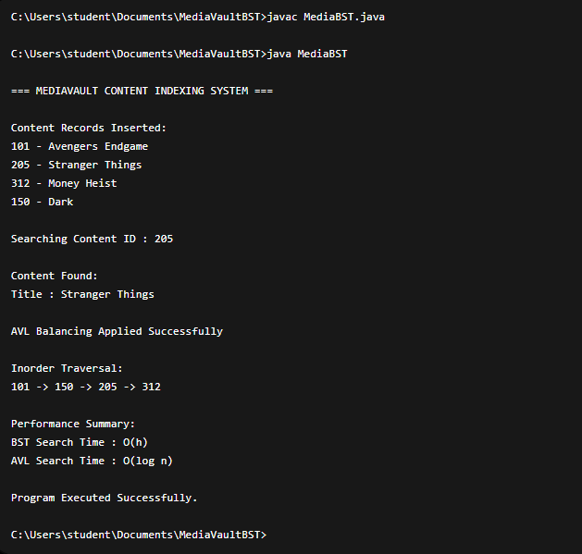

Result: Screenshots / Output
The AVL Tree maintained balanced indexing and improved retrieval efficiency.
Sample Output:
- Content ID: 101 → Avengers Endgame
- Content ID: 205 → Stranger Things
- Content ID: 312 → Money Heist
- Search Result: Content Found
- AVL Rotation Applied Successfully

Time Complexity:
- BST Search: O(h)
- BST Insertion: O(h)
- AVL Search: O(log n)
- AVL Insertion: O(log n)
- AVL Deletion: O(log n)

AVL Trees provided better performance than ordinary BSTs when handling large media datasets.
.

GitHub Link: https://github.com/yaswanthsurya-99/DSA-2
Student Signature Faculty Signature

